Team 3176 White Paper
Title: Image transfer into Carbide. | Author(s): Aidan Chapin/ Jillian Conway
Sub-team/Function: CNC | Subject: Awards for sponsors.
Date:2/17/2020 | White Paper Number: #1 AC/ #2 JC

Abstract

Awards are a big part of the robotics team. It is a way for us to show our appreciation for all the big companies that are supporting us and supplying us, but someone has to make these awards through a process called acrylics. The process of this is quite simple. You go into a program called “Carbide create”, and from there you enter your design after you enter your design, but what happens when you need to insert a logo or even an Image? Well the purpose of this white paper is to explain that process.

Main parts of Inkscape

Inkscape is a program that you can download on your computer for free. I have used it for a few different awards that I have made in Carbide. The process of separating the parts of the photo is a little tricky at first, but once you get the hang of it, it gets easier as it goes. In this White Paper we will talk you through the process of separating a simple logo, the Brownsburg Bulldog logo into carbide.
Steps

- The first step is when you are downloading Inkscape on to your computer make sure that it is version 0.92.4, and download it on to your device it might take a little while to download, but it doesn’t take too long.
- After Inkscape has downloaded on to your device open the app. Once you open the app on your device you should come to a screen that looks like this.
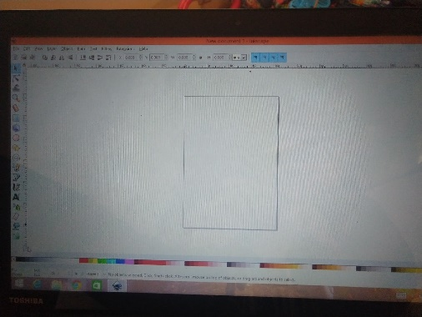
Once you see this screen you go to the top left corner of your screen and click on File after you do this go down to Import. Another short, simple way of doing this is just entering (Ctrl+I) after you do this you import the image that you want to transfer into Carbide. In our example we do the Brownsburg Bulldog symbol. When you go to Import the photo it will pop up with a box that will ask you how you want to import. It will say (Image DPI) Make sure the check is in the box that says (From File). It will also ask for the (Image Rendering Mode) make sure that the check is in the box that says (None(auto)) then just click Ok.

- After you Import your image you should come to a screen that looks like this.

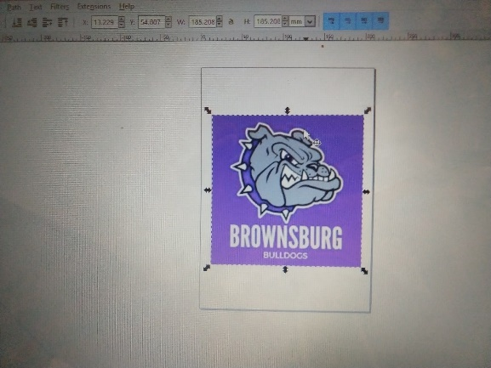

At the top of your screen you will see an option that says Path click on that and you will see a drop box menu you’ll see an option that says (Trace Bitmap) select this another faster way to get to this is (Shift+alt+B) once you click on Trace Bitmap. A box will pop up that box looks like this.
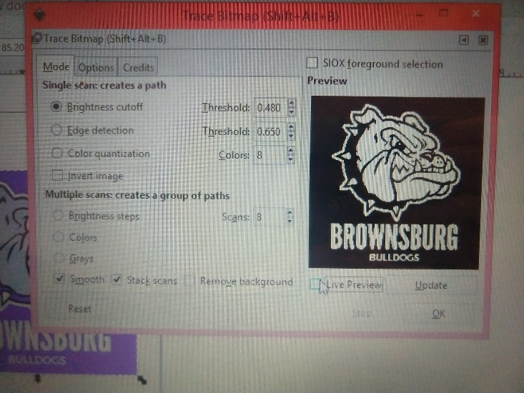

At the bottom of the screen where the mouse is on this image make sure that you click on the checkbox that says Live Preview this will show you your image over to the side there are three different options to choose from (Brightness cutoff, Edge detection, and Color quantification) check the box that says (Edge detection) once you do this your image on the screen should look like this.

Change the Threshold on the image to where you want it then hit Ok.
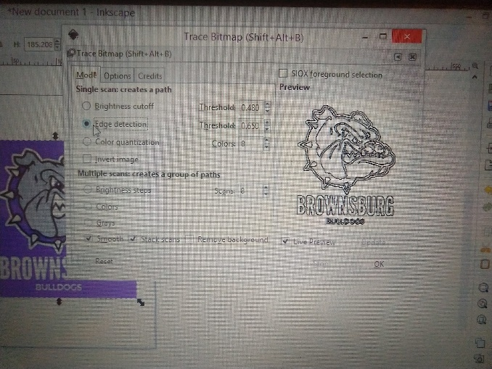

- Once you get your image the way you want it go to File and in the dropbox menu scroll down to Save as. Once that happens name your File what you want it to be named. But where it says Save as type you have to change it from an SVG to a DXF type file. On the computer that I use it looks like this.
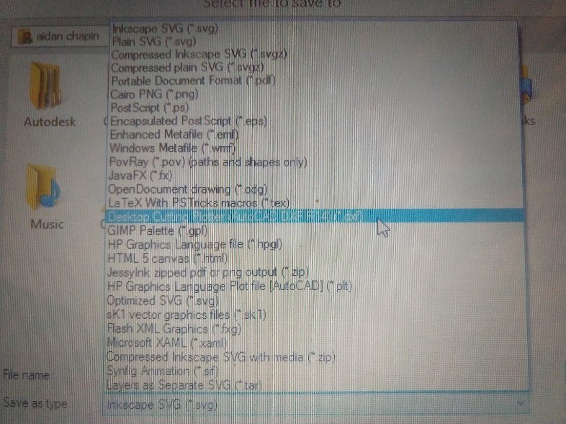

- Once you save the file onto your computer open Carbide Create. In Carbide create go to the option that says Import and click on Import External File once you do this go find your image in the folder that you saved it into. Once you have done this it will import into Carbide. In my personal experience all of my images that I have imported have been super tiny at first, and I have to scroll out a little to find them. Once you find your image change the width of the image, and that should fix your image.

This concludes the process of Importing an image from Inkscape into Carbide create Here are a few examples of some Sponsor/Team awards that I have designed using this process.
